|  |  |
| --- | --- |
| busnienss analysis  [Project Name] | **Abstract**  “The main aim of our project is to create a website that is helpful while selling car parts and connect vendors -Mechanical workshops- with users.  In addition to main objective we offer a stack car-flow which is the first car geeks Hub in Egypt”. |

________Table of Content_______

1. Overview
2. Problem
3. Solution
4. Target Audience
5. Profit
6. Flowchart

Overview  
In the Proposed System our main idea is to develop a system where we can have all the required information for the user “car owner” in order to effectively interest him in the process of checking his car parts periodically and change them when it required. We are connecting vendors -Mechanical workshops- with users to complete the purchasing car parts cycle.

our website can maintain and view all car parts details like manufacturer, price and using case if exist, location and contact of workshop etc. which are kept for sale effectively. With this Customer can get the information quickly which have been entered clearly.

In addition to main objective we offer a stack car-flow which is the first car geeks Hub in Egypt.  
  
  
Problem  
  
From our marketing research we found that:

* It is difficult for the owner of the car to find any spare parts, it takes a lot of time, and effort.
* There are different range of prices for the car parts and user can’t get the best part with suitable price.

* The car owner gets stuck 24/7 with car’s issues and there is no official Hub exist to get back the solutions immediately.

Solution  
  
In this section you will find the result that our system aims to achieve which are:  
  
  
The website will display all the products with information about them, their prices, and their availability in a mechanical workshop.

Vendors can post their items, contact information and their GPS location.

Users can view vendors items and get their information.

Admin can make changes and ban users and unban.

Stack cars-flow to upload your problem and get the right solution.

Target Audience  
In our project we target three segments of people:

|  |  |  |
| --- | --- | --- |
| Car Car owner | Welder  Mechanical workshop | Users   people that have an interest in cars and would like to learn how to get them, their prices and where to purchase them. |

Profit

we divided the profits income into three main parts:

* User subscription.
* Vendors subscription.
* Ads.

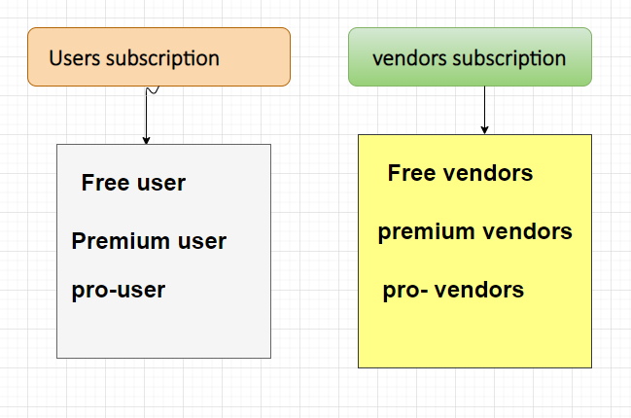

Flow chartIn this section we describe graphically what is the project functions  
  
 